Name: Nada Zorboska
E-mail: nada.zorboska@gaf.ni.ac.rs
Institution: University of Nis, Faculty of Civil Engineering and Architecture
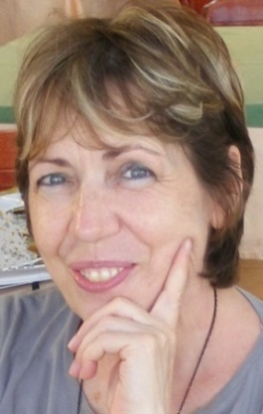 | PERSONAL INFORMATION  Date of Birth: 24/02/1955  Nationality: Serbian  Marital Status: Married  Number of children: Three  Address: 5 Vojvode Tankosica St. 18000 Nis, Serbia  Telephone: +381 18 588202, +381 64 2024096
EDUCATION AND CAREER
Pre-university education awarded with diploma "Vuk Karadzic" for outstanding success. MSc in Theoretical Mathematics at the University of Nis, Faculty of Sciences and Mathematics. Career positions:
- Professor of Mathematics at High school for six years ;
- Teaching assistant of Mathematics at University of Nis, Faculty of Civil Engineering and Architecture for twenty years ;
- Current position (from 2009) - Associate in the office of the Vice Dean for scientific research at the University of Nis, Faculty of Civil Engineering and Architecture, responsible for:
- development and implementation of the international project proposals in the frame of international programmes for modernisation of higher education, promotion of scientific research, academic mobility and networking for the exchange of knowledge, experiences and best practices;
- the process of accreditation of the Faculty of Civil Engineering and Architecture as higher education and scientific research institution and of the faculty study programs;
- activities related to research projects of the Ministry of Education, Science and Technological Development.

PERSONAL SKILLS AND COMPETENCES
- Language skills: Serbian (native), English (B2), Macedonian (effective operational proficiency);
- Teaching skills, organisational skills;
- Computer literacy;
- Driving licence (category B).
Project number: 573806-EPP-1-2016-1-RS-EPPKA2-CBHE-JP

"This project has been funded with support from the European Commission. This publication reflects the views only of the author, and the Commission cannot be held responsible for any use which may be made of the information contained therein"

